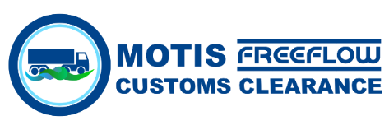



**EXPORT / TRANSIT**

Form of General Indemnity in Respect of Community Transit Documentation

To: ……………………………………

In consideration of your giving an undertaking in respect of a Community Transit operation upon our instructions, we hereby indemnify you in respect of all and every liability which may be imposed upon you in respect of the said Community Transit operation, and we undertake to make payment to you forthwith and reimburse you in respect of any expenses incurred by you by way of Duties, Taxes, Levies and any other charges whatsoever for which you may become liable as a result of giving such an undertaking.

……………………………………. accept all kinds of financial, legal and criminal customs liabilities including the customs taxes and duties in the event that a transit document is not discharged regardless of the guarantee relation between MOTIS IRELAND LIMITED and ……………………………………….

Dated this…………………… day of …………………………………… 2021

For and on behalf of

…………………………………………………………………………

Address………………………………………………………………

…………………………………………………………………………

Signed………………………………………………………………

Full Name…………………………………………………………

(Block Capitals)

Position Held………………………………………………………

Company Stamp.